1. Exhibits table should look like this (please note the rows) RE-ARRANGED AS REQUIRED

|  |  |  |  |  |
| --- | --- | --- | --- | --- |
| **Photo** | **Category** | **Quantity** | **No. of pieces** | **Description** |
| Image | Wildlife species: | Wildlife: NA | Wildlife: NA | Wildlife: |
| Image | Specimen: | Specimen: 10kg | Specimen: 12 | Specimen: |
| Image | Implement: | Implement: | Implement: | Implement: |
| Image | Other: | Other: | Other: | Other: |

2. Under suspect tab, on the table for suspects without arrest information e.g. REMOVED AS REQUIRED



When adding arrest information at the end remove the two question and let them appear under court information form

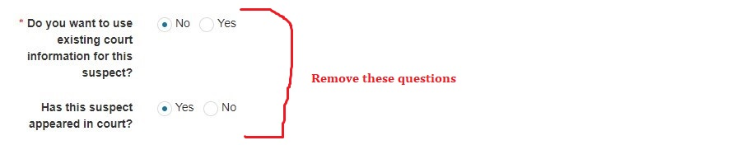

3. When creating a new case, the specific court status when one chooses **convicted**, the questions

Was suspect jailed Yes, No

Was suspect fined Yes, No

Etc…..

When one selects yes the system does display the more information like jail date, jail period etc.

ISSUE FIXED AS REQUIRED

